iCare — Urgent UI Changes Document

Change 1: Public Home Page — Redesign Based on OlaDoc Style

Reference / Inspiration
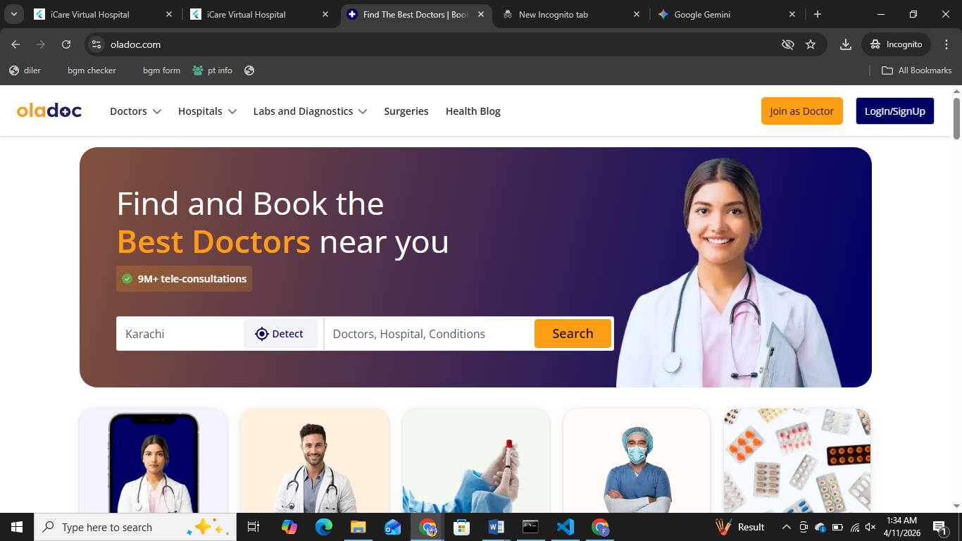
The new iCare public home page should follow the same style and layout approach as OlaDoc's homepage.
- Top pe left pe logo only
- Top right pe Signup | Sign in | Work With Us ke buttons
- Banner without search bar within banner
- After banner Doctors List in carousel format (Doctors Names and Pictures should be on the carousel) Heading of this carousel = Connect To Doctor
- After Doctors carousel we need another carousel of ‘Pharmacies’. Heading of carousel = Pharmacies
- After Pharmacies carousel we need another carousel of ‘Laboratories’. Heading of carousel = Laboratories

Current State of iCare Public Home

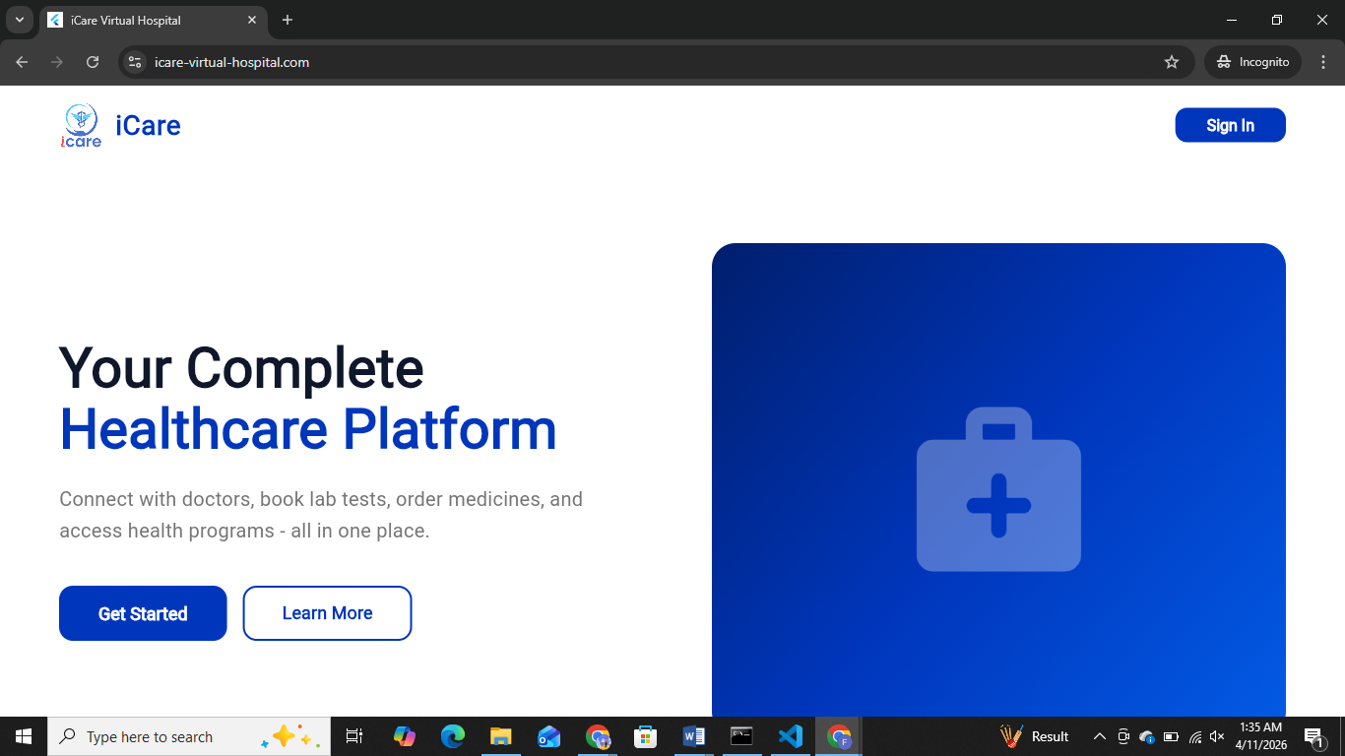
The current public_home.dart has only one button in the top navbar:
- Sign In (right side only)

Required Change
The top navbar should have 3 buttons on the top right, in place of where Sign In currently sits:

[ Sign In ] [ Sign Up ] [ Work With Us ]

Button | Action
Sign In | Opens the existing login screen
Sign Up | Opens patient-only signup
Work With Us | Opens professional signup — Doctor, Pharmacy, Lab only

Sign Up Button — Patients Only
- Normal Sign Up opens signup for patients only
- All other roles (Doctor, Pharmacy, Lab, Student) are removed from this flow
- Currently when Sign Up is clicked, Doctor and Pharmacy options also appear — those need to be removed

Work With Us Button — Professionals Only
- Clicking Work With Us opens a role selection with exactly 3 options:
  - Doctor
  - Pharmacy
  - Lab
- Student is NOT included in Work With Us

Student Role — No Signup Required
Student has no signup screen anywhere — not in Sign Up, not in Work With Us.
Student access is handled internally. After login from any role, user can go directly to LMS / My Courses. No separate signup flow is needed for students.

Files to Modify
- lib/screens/public_home.dart
- lib/screens/select_user_type.dart
- lib/screens/signup.dart

Change 2: Post-Login Home Page — Remove Right-Side Panel

Current State
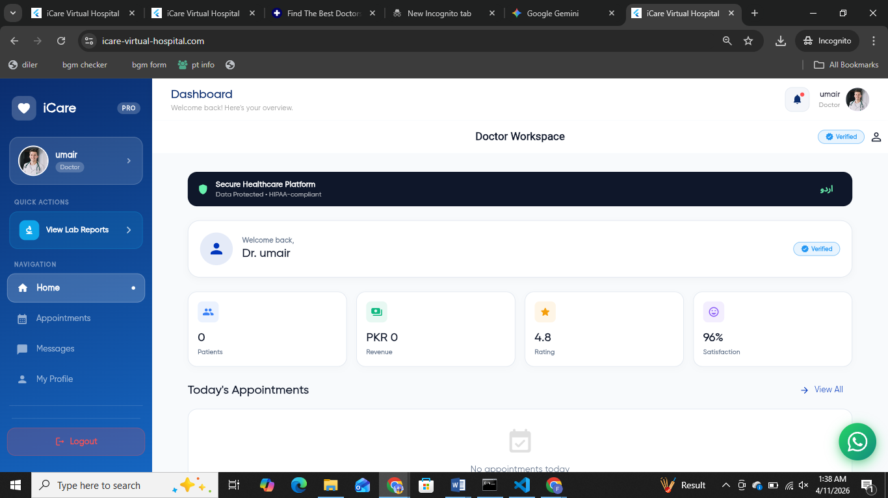
After login, the home screen currently shows a right-hand side panel with a long list of details My Appointments, Reports, and many other items.

Required Change
- The entire right-hand side details panel is to be removed completely
- All those items (My Appointments, Reports, etc.) already exist in the left-side navigation so they do not need to appear on the home page again
- After login, the home page should show the same layout as the public home page (the one visible before login)
- The only addition after login will be the left-side navigation drawer

Files to Modify
- lib/screens/home.dart (or whichever screen loads after login)

Change 3: Left Navigation Drawer — Remove Top Section

Required Change
Remove everything above the navigation list in the drawer:

- ❌ Heart icon — remove
- ❌ "iCare" text — remove
- ❌ Profile photo circle — remove
- ❌ Edit icon on profile — remove
- ❌ User name — remove
- ❌ User email — remove
- ❌ "My Reports" label or any label above the navigation list — remove

What stays / changes:
- ✅ iCare logo image only (logo.png) at the very top — no text beside it, no icon beside it
- ✅ Navigation section label renamed to "My Account"
- ✅ All navigation items remain exactly as they are

Files to Modify
- lib/navigators/drawer.dart

Change 4: Profile — Remove Duplicate, Keep Top-Right Only

Required Change
Profile is currently appearing in 2 places:
1. Top-right corner of the main screen
2. Inside the left drawer (profile photo + name + email)

- Once the right-side panel is removed (Change 2), the top-right profile that was on the home page will also be gone
- The drawer profile (photo + name + email) also needs to be removed (covered in Change 3)
- Only the top-right profile icon remains — nothing else

Files to Modify
- lib/navigators/drawer.dart

Change 5: Change and/ or Remove in Left Navigation
Required Changes:
- Life Style Tracker – Instead of Current values just show coming soon. This is part of Gamification and should be left blank for now.
- Change the name ‘Manage Dependents’ into ‘Emergency Contacts’
- Change the name ‘Diagnostics Support’ into ‘Laboratories’
- Change the name ‘Medication Fulfillment’ into ‘Pharmacies’
- Within setting delete the word ‘Danger Zone’ for delete account

Summary

# | Change | Files | Status
1 | Redesign public home page like OlaDoc, add Sign In + Sign Up + Work With Us to navbar | public_home.dart, select_user_type.dart, signup.dart | ⏳ Pending
2 | Remove right-side details panel after login, show public home layout | home.dart | ⏳ Pending
3 | Remove drawer top section (heart icon, iCare text, profile, name, email), keep only logo, rename nav to "My Account" | drawer.dart | ⏳ Pending
4 | Remove profile from drawer, keep only top-right profile icon | drawer.dart | ⏳ Pending (part of Change 3)

